Alex Arnold

NETLAB+: NDG_Forensicsv2_Lab_21 - Chain of Custody

8-21-2024

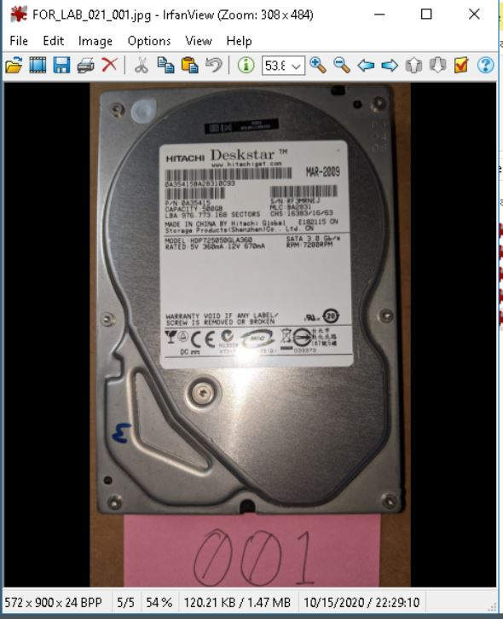

* 1.4 - Hard Drive image

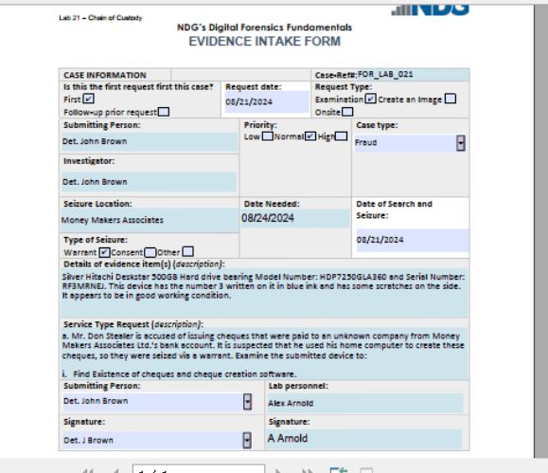

* 2.12 - Completed intake form

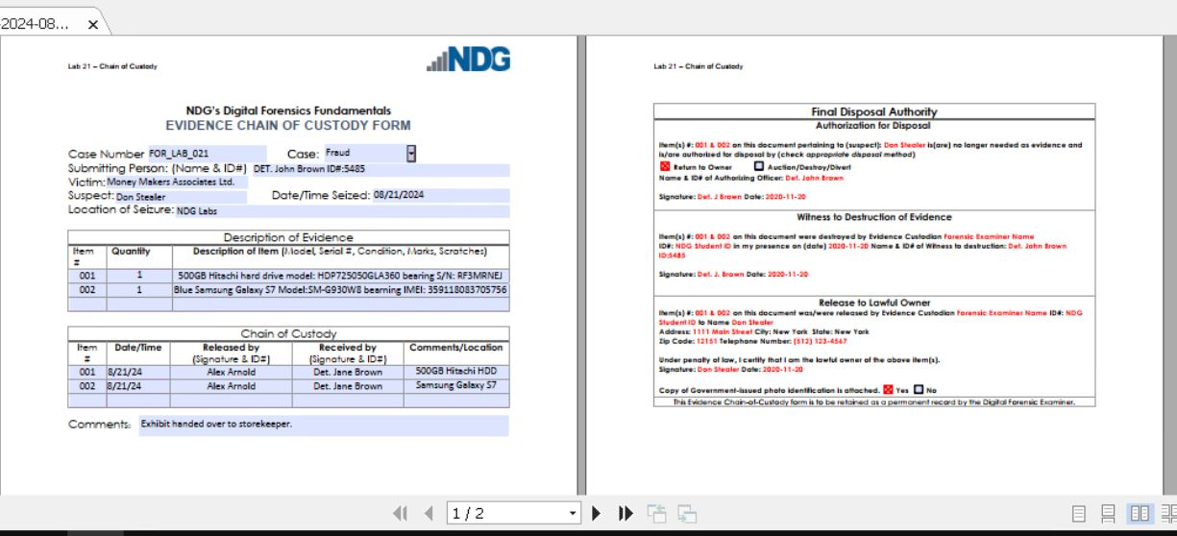

* 2.21 - Chain of Custody screen

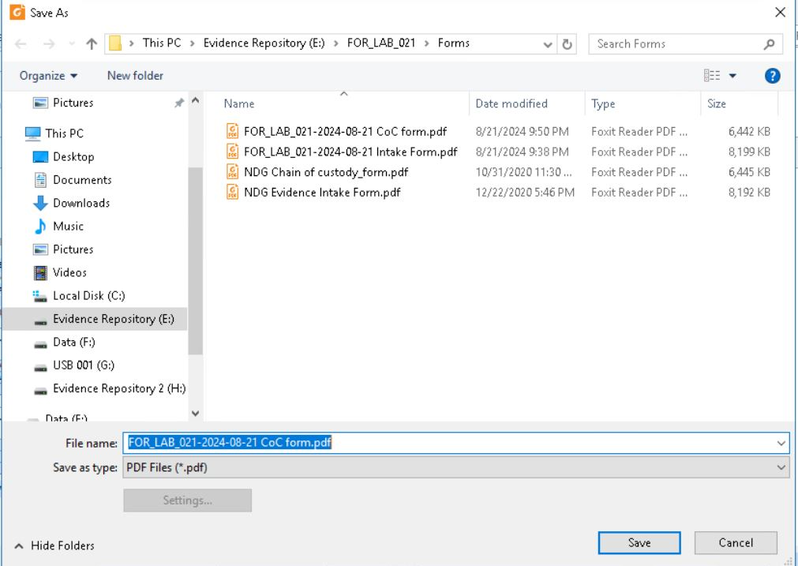

* 2.26 - Windows File Explorer "Save As" screen, showing new name.